Professional Writing—Colleen Kolba
Information Design Feedback File

A note from the instructor about the feedback file:
This feedback document is designed to offer you comprehensive feedback on your information design project, based on the common issues that appeared on projects throughout the entire class’s drafts. You will be shown real examples from the class and be offered concrete advice & reminders about how to fix these common issues. The purpose of this feedback method is twofold: 1) feedback provided is more thorough, as you will be shown a wide variety of examples and given revision direction 2) you will be required to demonstrate some agency and self-awareness of your own work—you aren’t going in and mindlessly “fixing” the few things your instructor pointed out. Rather, you’re developing critical thinking skills for revising your own work in a professional environment. For more information, see the “Collective Feedback” section of the syllabus.

You will notice your own work pop up an example once or twice. Please note that every single student has a small portion of their work used in this document. Just because your project was used as an example doesn’t mean it was the “worst.” Alternately, just because your project wasn’t used as an example for a particular issue doesn’t mean that the issue doesn’t apply to you. You must consider each feedback item against your own project. Finally, all identifying information has been omitted from examples to protect your privacy and to allow the examples to remain anonymous.

What you’ll find in the feedback file:
The feedback file is organized by rhetorical concerns, visualization concerns, and considerations for writing. Each section will be clearly titled with the resume element that is being addressed, describe the common issue, show an example of the issue in a screenshot, and then offer advice as to how to fix the issue.

How to use the feedback file:
1. Go through each item presented in this document while looking at a copy of your own resume
a. Ask yourself: Is this a mistake I’m making on my resume?
b. Based on the description of how to revise this mistake, have I executed this skill correctly? (This is important, since the example mistake may not look quite the same as yours)
c. Read every section fully, even if you don’t think it applies, since some items address multiple concerns
2. Make the revision, based on the advice given
3. Move onto the next section
4. After going through the entire file, review the other project content you’ve been provided with (information design swipe file, the RAWWr5 readings) to see if there is anything additional to address
5. Review the final rubric on Canvas to make sure you’re executing all areas of assessment correctly
6. Proofread your project for standard English grammar & punctuation
If you have any questions, do not hesitate to reach out to Colleen at cakolba@usf.edu
Purpose
1. What is the purpose?
Description: Ask yourself this question and make sure you have a specific answer. Does your information design have a specific point? Is the point clear? The more specific and clear your purpose is, the better your project will be.
Example:
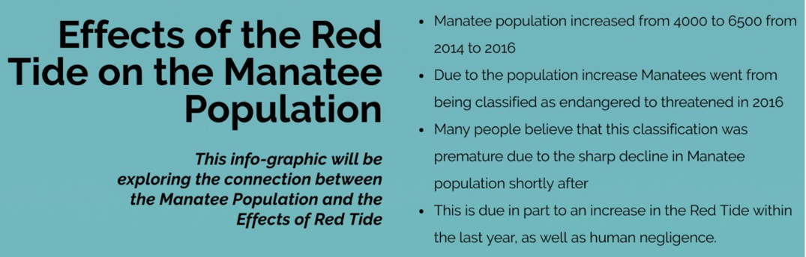
Revision: The above example clearly states in the title exactly what the purpose of the infographic is: to demonstrate the effects of red tide on manatees. The writer also includes a sub-title re-stating the purpose; however, they can remove this, since they’ve already made it so clear through the title and other content what the purpose is.

2. Clear takeaway
Description: What should the reader walk away thinking after reading your project? What are they meant to do with this information? The project should conclude with a clear takeaway (see #3 below for one method for creating a succinct, logical takeaway)
Example:
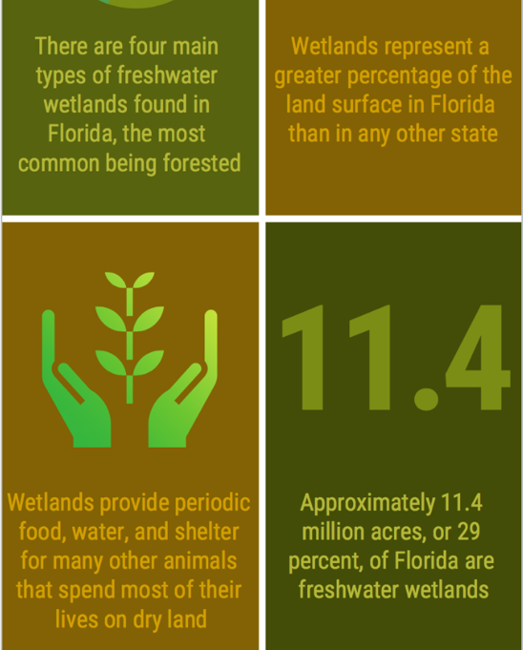
Revision: The above example clearly informs the reader about freshwater wetlands, particularly in Florida, so there is a clear purpose: to inform the reader on this topic. However, this writer could strengthen their work even more by including a clear point—what do we do with this information now that we have it?

3. Call to action
Description: Consider giving them a specific call to action; if you’re ‘informing’ your audience, what do you want them to do with this information?
Example:
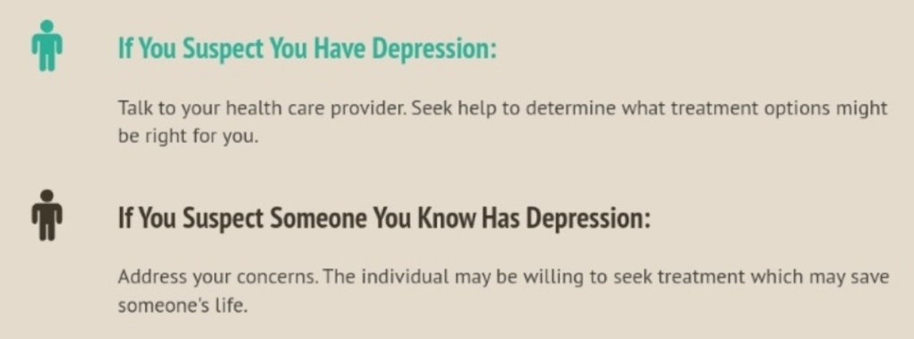
Revision: In this example, the writer, whose project gave facts about depression, concluded her project with two clear calls to action. The reader isn’t left wondering what they should do with this information, since the writer offers two clear responses and concrete actions that can be taken now that the audience is informed.

Audience
1. Who is your audience?
Description: If your answer is “everyone,” your purpose isn’t clear enough. If you’re having difficulty figuring out the audience, ask yourself, who can take action using this information? Who has a stake in this information?
Example #1:
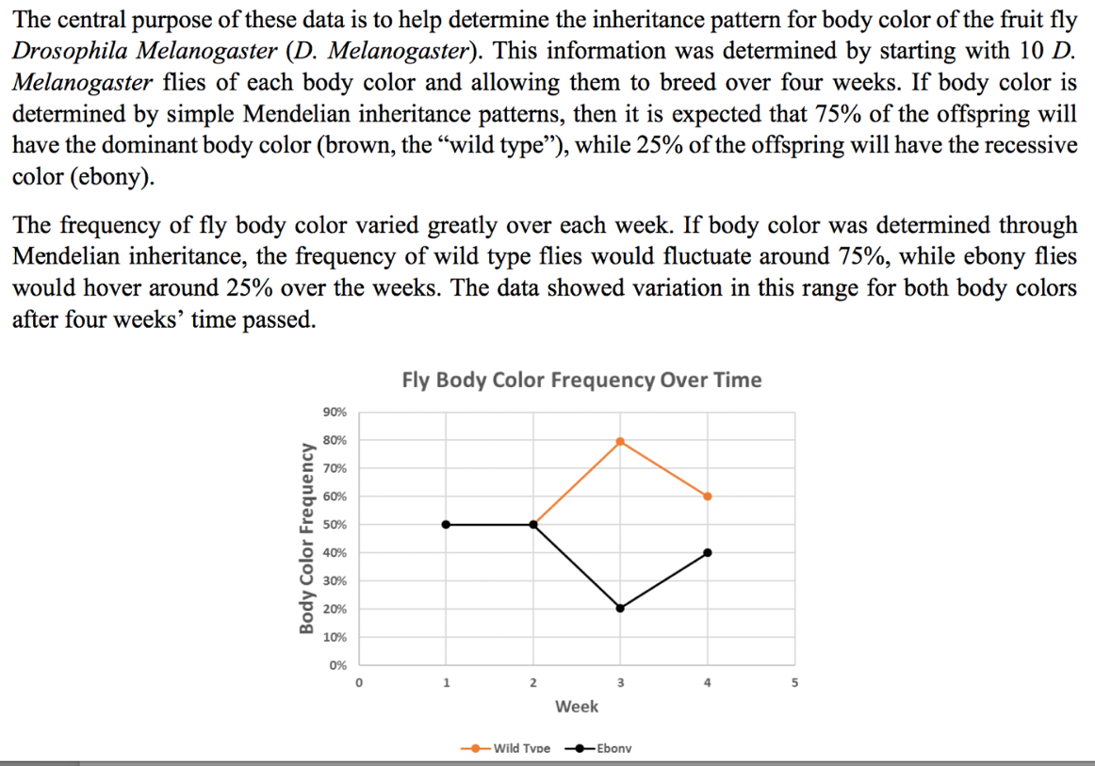
Example #2:
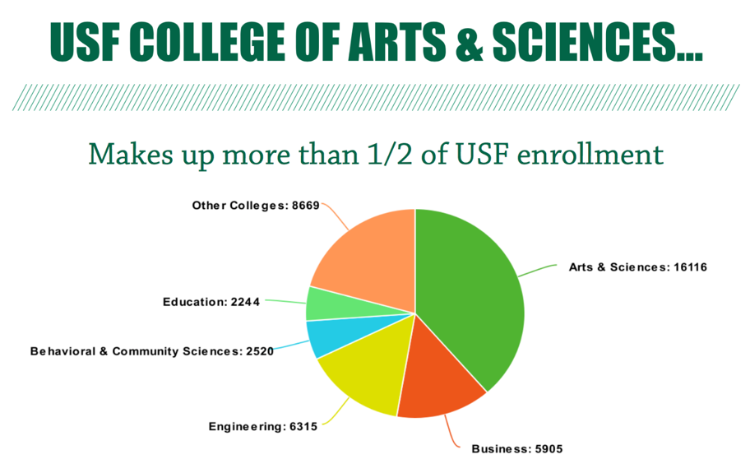
Revision: In examples #1 & #2, we see each writer consider who their audience is. In example #1, the writer is detailing the results of a scientific experiment. Because the audience here is other scientists, the design and information is presented in a more “traditional” report format, since the readers will be familiar with the jargon and likely have the time and patience to read a little more. In example #2, the audience is informing potential students or undergraduates about the USF College of Arts and Sciences. Since the audience will be looking for quick information, the writer has created a simple, easy-to-read pie chart that shows a breakdown of USF enrollment. Almost everyone in our class will likely have an audience similar to example #2—an audience with very little time, looking for quick information.

2. Audience & purpose connection
Description: If the purpose is clear and the data set specific, the audience will usually be clear as well
Example:
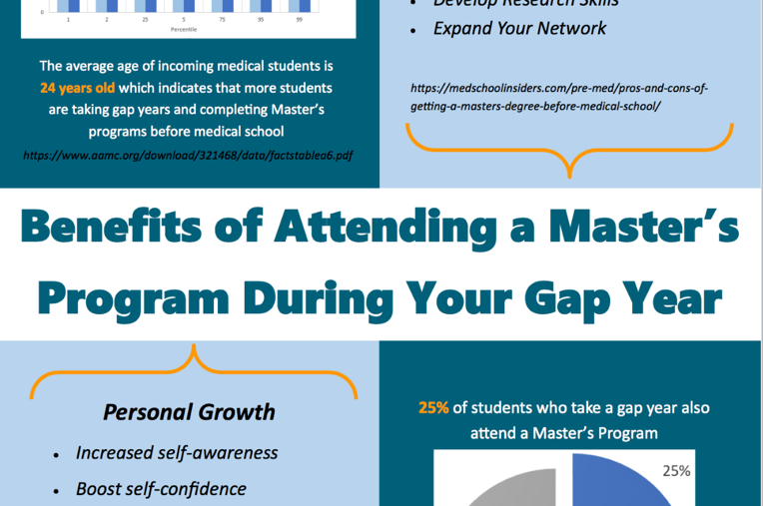
Revision: In the above example, the writer states a clear purpose (highlighting the benefits of pursuing a masters during a gap year before medical school) which is directly tied to the audience (undergraduates planning on attending medical school and considering not only a gap year, but pursuing more education during that gap year). Because the purpose of the data is so clear, it’s easy to identify the target audience without the writer ever having to say “My target audience is…”

3. Choose a “real life” and specific audience to design for
Description: Your project should be designed for an audience that needs/would find this information relevant. This means the entirety of the project should be designed to look like something you would hand directly to the audience. That said, there should be no information about the class, instructor, project name, etc on your Information Design.
Example #1:
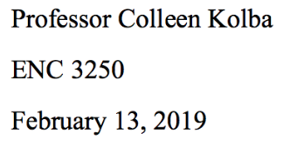
Example #2:
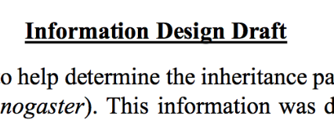
Revision: In both examples, information about the class and the project appear on the information design itself. If you’re creating a one page handout for your audience, this is not information you would include. All details similar to what we see in example #1 and #2 can be omitted. Because this project is submitted digitally, I’ll know who turned in what, so you don’t have to worry about including identifying information.

Title
1. Title your Information Design
Description: You must title your information design (and it should not be titled “Information Design” or “Project 3” etc). A good title is specific and offers context for the information that follows.
Example #1:
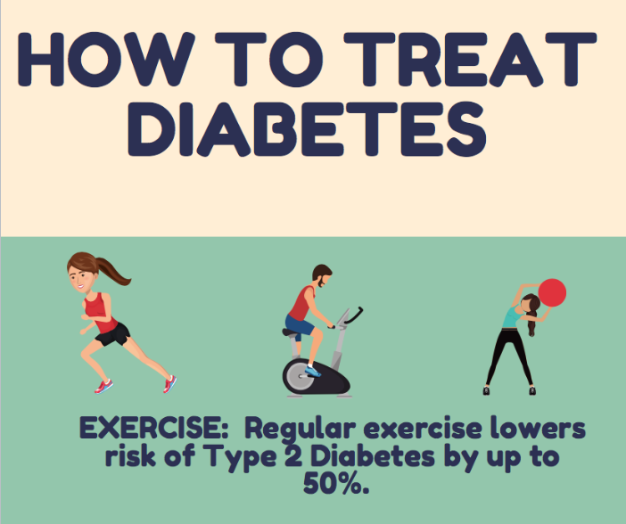

Example #2:
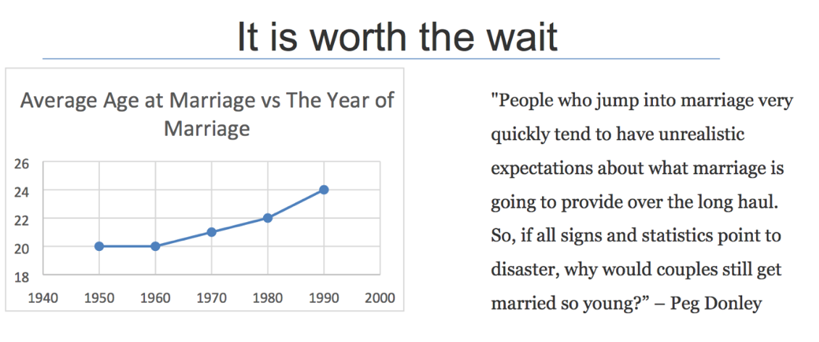
Revision: The title in example #1 makes it absolutely clear to the reader what the content of the project will be: how the intended audience can treat their diabetes. The title clearly previews the information that we can expect to find throughout the infographic. Example #2 uses a catchy title, but lacks a little clarity (a reader might ask, “Is what worth the wait?” I would suggest that this writer keep the creative title, but add a little more information, such as: “Is it worth the wait?: The best age to get married.” That will keep the attention grabber, while also making the topic clear.

2. Consider using a question
Description: A question makes a great title, because the topic is clear, the purpose is clear, and we know that the information that follows will answer that question.
Example:

Revision: In the above example, the writer incorporates “Why should you care about brand colors?” in their title. We know the topic will be about color, but, more importantly, the purpose is super clear: brand colors are important and this infographic will show you why. Additionally, if you have a clear question, you can use it to revise your project. Does your project answer the question? Does it answer the question persuasively? Have you included information that is irrelevant to the question and might therefore be cut?

While it’s not a requirement, including a question is a great way to focus your purpose and overall project.

Visuals
1. Required number
Description: 3 data visualizations are required for your project. They can take many forms, but there must be at least three. You may use more than three if you’d like, but you must have at least three.
Example: N/A
Revision: Does your project have at least 3 data visualizations? If the answer is no, make sure you add more to meet the requirement, otherwise your final project will lose major points—this is a visuals and design project, after all!

2. Must be created by you
Description: You must create the visuals yourself. While we’re using others’ data, you are required to be the one to “visualize” it. There are many tools available, from Microsoft Word to infographic generators online. This stands for any kind of visual you create, including picture/drawing visuals. If an image is going to count as one of your 3 visuals, it must be a picture, icon, or drawing that you’ve created (or picture you’ve taken).
Example:
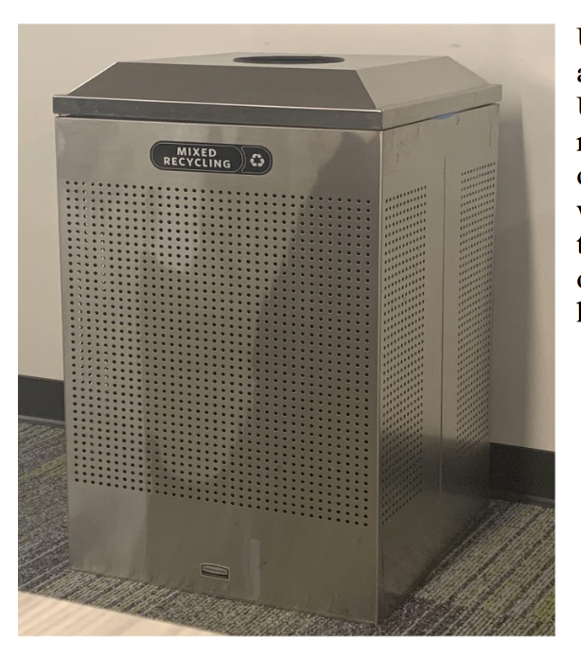
Revision: The above writer chose to include a picture of an on campus recycling bin, in order to effectively show their audience what to look out for when searching for recycling on the USF campus. This sort of visual is fine, as long as the writer has taken the picture.

3. Clearly label your visuals
Description: Your visuals should all have very clear labels: title, each axis, values, etc. You want to avoid any confusion on the part of the reader.
Example:
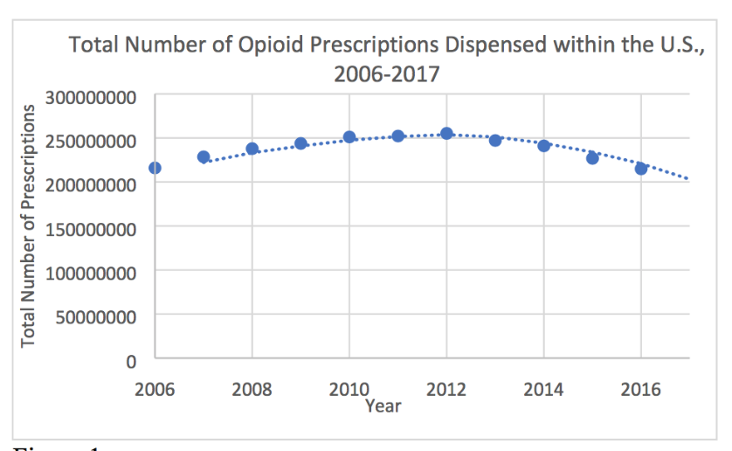
Revision: In the example above, the writer has clearly titled the graph, labelled each axis, so we understand what the numbers mean. One way this graph might be made even more clear, is to short-hand the y-axis, since the numbers are very long. For example, labelled the axis as “Total number of Prescriptions in the millions,” which would allow them to shorten the values to 50, 100, etc.

4. Utilize legends
Description: Don’t forget to utilize legends, which will allow you to keep your visuals really “clean.” When you’re labelled everything to ensure clarity, sometimes it’s easy to put too many words or numbers, which may ultimately make it harder to read.
Example:
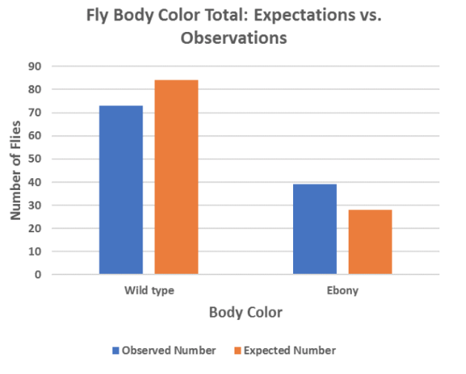
Revision: The above example utilizes a legend to note what each color means. This works especially well here, since writing “observed number” and “expected number” on the bar graph would add unnecessary distraction visually, even though this is important information. Look at your charts and graphs when revising and see where you might utilize a legend to make your visuals easier to read.

5. Make sure the visual can be easily read at a glance
Description: Your project should be easy to read and your visuals understood quickly. The purpose of visualizing data is to make reading and understanding easier for the audience, so make sure you’re doing everything you can to allow them to do so.
Example: n/a
Revision: Have a friend or family member read your project. Don’t give them any context or tell them what they should be able to understand. Instead, ask them what wasn’t made immediately apparent when quickly reading through your work or looking at your visualizations. Then, revise to make it easier to read, so they wouldn’t have any questions.

Clarity
1. Quick to read
Description: Just as your visuals should be read at a glance, your entire project should be easy to read. Consider who your audience is and how to most efficiently convey your purpose.
Example:
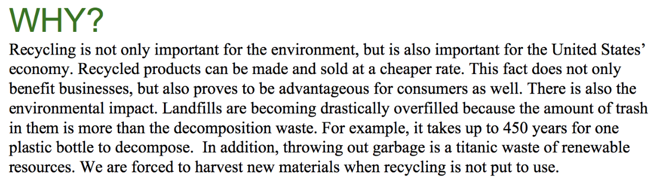
Revision: The above example is text-heavy. Since the target audience is college students, the writer might consider ways to more quickly communicating the “why” reasoning behind recycling. The writer has already done an excellent job clearly marking the information that will be covered via the question, but the info in here might be design to be read “at a glance.”

Citations
1. Your work must be cited
Description: You must include citations for your data sources.
Example:
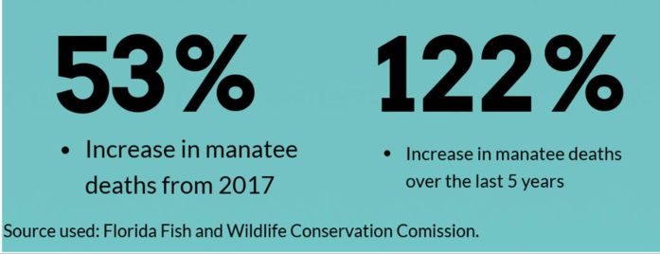
Revision: You must cite the source of your data. However, you shouldn’t create a works cited page. The above example does a great job quickly but clearly citing the data source. It’s easily read, but does not distract from the overall project design. Like the information, the source should be easily accessed for the reader. You can keep the citation tiny and include it at the bottom of your page or below the various visualization that use the data. You only need to include the source title and publication.

Written Portions
1. Writing should offer context or what can’t be seen through the visuals
Description: The writing that you include in your report should only serve to contextualize or tell the reader information that can’t be known from looking at the data visualizations you’ve included.
Example:
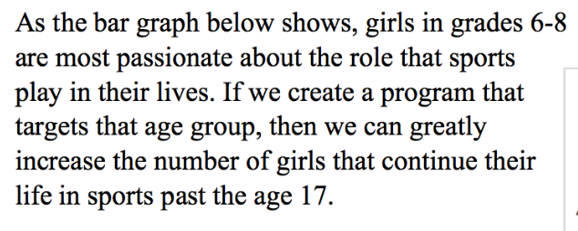
Revision: The example above demonstrates how data can be contextualized. The writer references the bar graph shown, but doesn’t simply describe what we can obviously see. Instead, the writing analyzes and contextualizes the data, offering action the audience can take to encourage more girls to participate in sports.

2. Writing must be your own, otherwise it’s plagiarism
Description: All writing included in the report must be your own, original work.
Example: N/A
Revision: Whether it’s titles, offering context, or adding a call to action (among others), this writing must be done by you. The exception here is if you’re quoting qualitative data from your data source. Otherwise, you may not use writing from your original data source. Go through your project and make sure you’ve done all the writing and that the visuals are properly cited to avoid plagiarism.

3. Break up large blocks of text
Description: Break up large portions of text to make your information more accessible. As this entire feedback file has addressed, we want to make the information easy to read and access by our audience.
Example: See Example #1 in this section
Revision: While the information provided here adds strong context and analysis, the writer might consider changing the “look” of the text itself, so it less resembles a paragraph in a paper (which might look daunting to read) and more like a splashy “quick fact” through larger font size, incorporation of color or a shape/box around the text.

One Single Page
1. Your entire project must fit on one single page
Description: Your project should be one full page. No longer with no exceptions.
Example: N/A
Revision: Make sure your project is only one page and no longer before you turn it in. This includes
your citations, which should not be on a separate page.

Proofread
1. Proofread your work
Description: Make sure you’ve carefully proofread your work for punctuation, grammar, usage issues. This is absolutely critical, because some design software used to create these projects don’t catch these errors. Additionally, because there is less “writing” here, similar to a resume, the expectation is that there are no errors.
Example: N/A
Revision: Have a friend or family member carefully review your work for errors. Read your work out loud to yourself to catch any errors, as well as to edit for clarity on the sentence level.

